Risk Management Program Finder Application

**Data Editor**

<http://www.medicalmutualintranet.com/admin/rm-program-calendar/>

**Fields**

**Data Set Name:** Internal reference to the data set you are working with. This can be helpful to leave information on which company or year this data applies to.

**Loading Data**

Use the “Open JSON”  button at the top right to load a data file. Files must be a JSON text file. The extension can be .txt, .js, or .json. This will clear and replace any information entered into the editor.

**Notes:**  
*Ideally a .json file should be used, but the current servers are not configured for the .json mime type.  
If the file does not load the first time, try again, or try renaming the file to a .json extension.*

Saving Data

Use the “Download JSON”  button at the top right to save the current data. This will produce a JSON file with all the information currently entered in through the editor. Name files with the extension .js or .json.

Locations

<http://www.medicalmutualintranet.com/admin/rm-program-calendar/#!/locations/>

**Adding a Location**

Use the “+ New Location” button to add a new location. Clicking this button will insert a new blank location and show the location editor.

**Fields**

* **Location Name:** Internal name for reference. This is the name you will see when attaching this location to an Event. Give it a name that allows you to quickly identify the location when entering events.
* **Facility:** Name of the building or facility where the event will be held. This will be displayed to end users to identify the address.
* **Address:** The street address to the facility. This should be a fully qualified address containing a street number, street name, city and state. E.g. “225 International Circle, Hunt Valley, MD”. Zip code is optional.
* **Latitude & Longitude:** GPS Coordinates to the address entered. These fields will be automatically populated after pressing the “Get Lat/Lng”  button. This is **REQUIRED** for the map to work correctly after updating the address. Pressing this button will also update the map with the new address and GPS coordinates.
* **Display:** The City and State of the location. The City is used to organize the “Location” drop-down menu in the application and will be displayed on the rendered map.

**Updating**

Use the “Select a Location to Edit” drop-down menu to change to an existing Location.

To commit updates or changes to the Location in the editor, click the blue “Save”  button at the bottom right. This will prompt you to confirm committing of the changes.

**Deleting**

To remove a Location, click the “Delete”  button at the bottom left. This will prompt you to confirm removal of this location. Any events attached to this location will become unlinked. Be sure to remove these events, or attach them to a new location.

Topics

**Adding a Topic**

Use the “+ New Topic”  button to add a new topic. Clicking this button will insert a new blank Topic and show the Topic editor.

**Fields**

* **Topic Title:** The display name for the topic as it will show up in all references within the editor and public application. This includes the Editor, Search drop-down, Program Description.
* **Presented By:** This line is used in the Program Description just above the “Register” Button.
* **HTML Editor:** This is a basic formatting editor for the program description. AVOID PASTING DIRECTLY FROM WORD. This will include numerous embedded styling and entity characters that could potentially break the styling of the program descriptions view.

**Updating**

Use the “Select a Topic to Edit” drop-down menu to change to an existing Topic.

To commit updates or changes to the Topic in the editor, click the blue “Save”  button at the bottom right. This will prompt you to confirm committing of the changes.

**Deleting**

To remove a Topic, click the “Delete”  button at the bottom left. This will prompt you to confirm removal of this Topic. Any events attached to this topic will become unlinked. Be sure to remove these events, or attach them to a new topic.

Events

**Adding an Event**

Use the “+ Add Event”  button to add a new Event. Clicking this button will open a modal window to input information pertaining to the event.

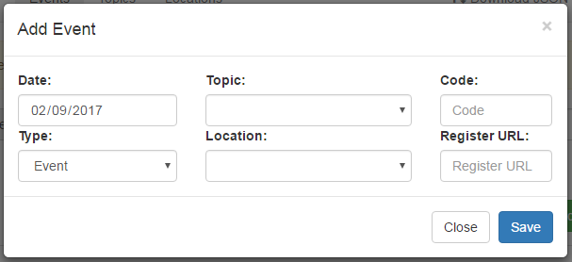

**Fields**

* **Date:** The date of the associated Event. Events are ordered by and attached to the program calendar by this date.
* **Topic:** Topic that this Event will cover. You do not have to attach an Event at this time, however it is recommended to enter the Topics first. A Topic must be assigned to each Event.
* **Code:** Program Code. This will be one of the search parameters and will show up in the search drop-down menu.
* **Type:** The “Type” of event.
  + **Event –** The standard event. A Topic, Location, Code, Register URL should be attached.
  + **Event Special –** Displays a special Purple colored event. Helps designate Office Staff events.
  + **Home Study –** Sets a flag for a home study event. Topic, Code, and Register URL are required. Date can still be set to control where the event shows up in order (beginning/end/middle), however the date will not be displayed. “Home Study” will be displayed instead of a date.
  + **Online Course –** Same as “Home Study”, except “Online Course” will be displayed instead of a date.
* **Location:** Location to attach to this event. Required for all event types except “Home Study” and “Online Course”
* **Register URL:** The URL to navigate to when “Register” button/link is clicked for this event.

asdf